Assignment 9
Members: Edgar Castellanos, Brian Batinchok, Jesse Lambert, Alex Lorenzo, Ryon Riley, Ian Vigrass
- G0/0 and S0/0/0 on R1 Configuration
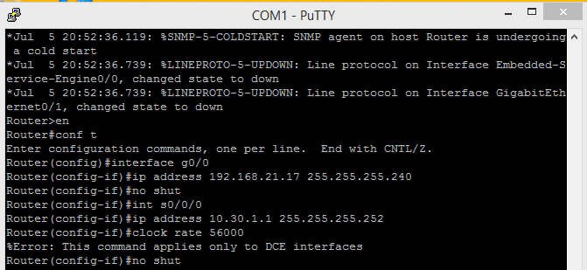

- G0/0 and S0/0/1 R2 configuration
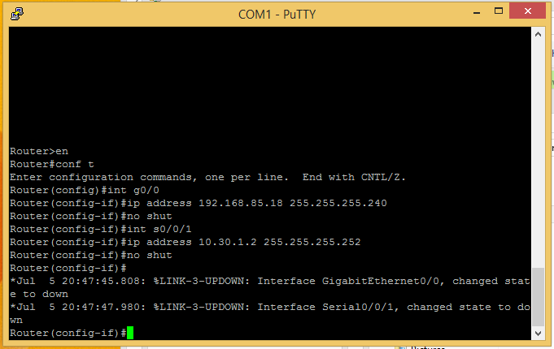

- Hostname LAN-A
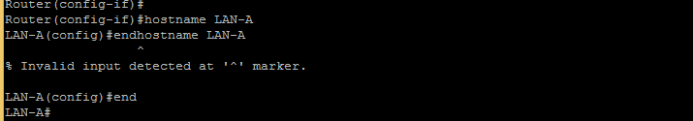

Hostname LAN-B
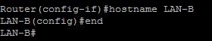

- Show ip interface brief
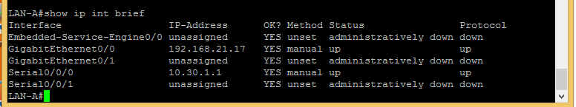

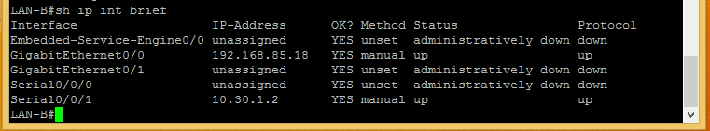

- EIGRP Configuration
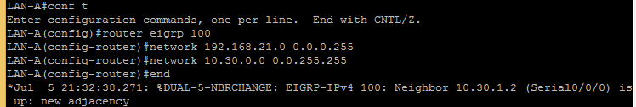

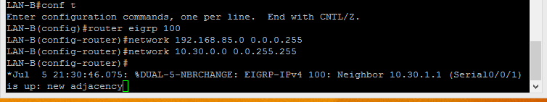

- Show ip route
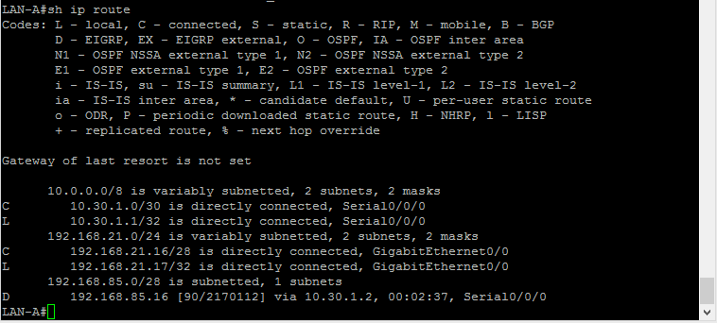

- PC1 and PC2 ping
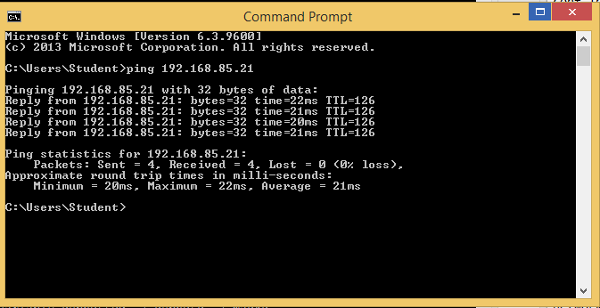

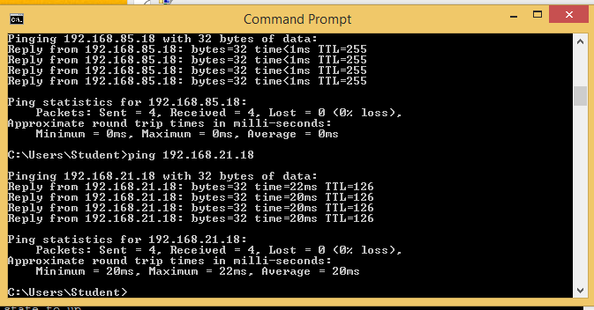

- LAN-B tracert
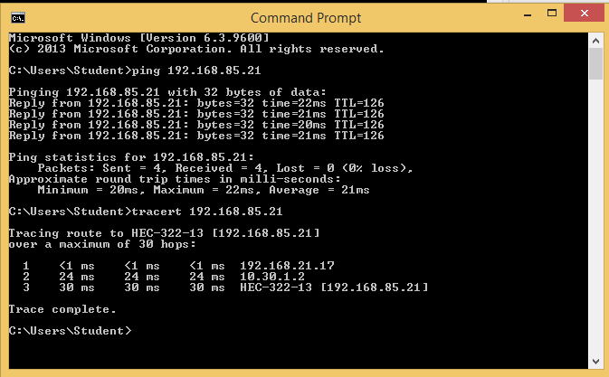

- Show ip eigrp neighbors
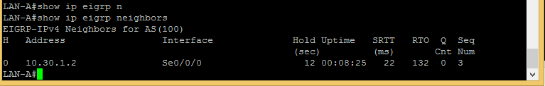

- LAN-B Telnet configuration
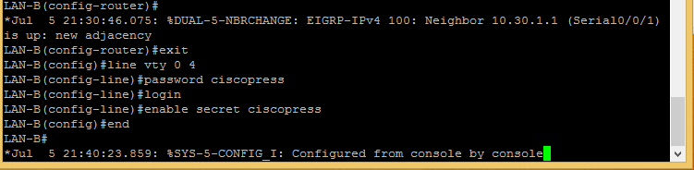

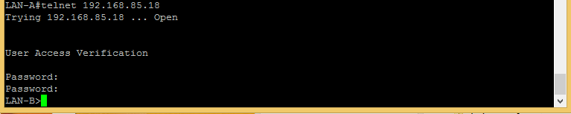

- Copy running-config startup-config
